ASSIGNMENT – 29.12.2023 YAZHINI S

AZURE DATABRICKS

🡪Searching Azure Databricks in Azure Platform

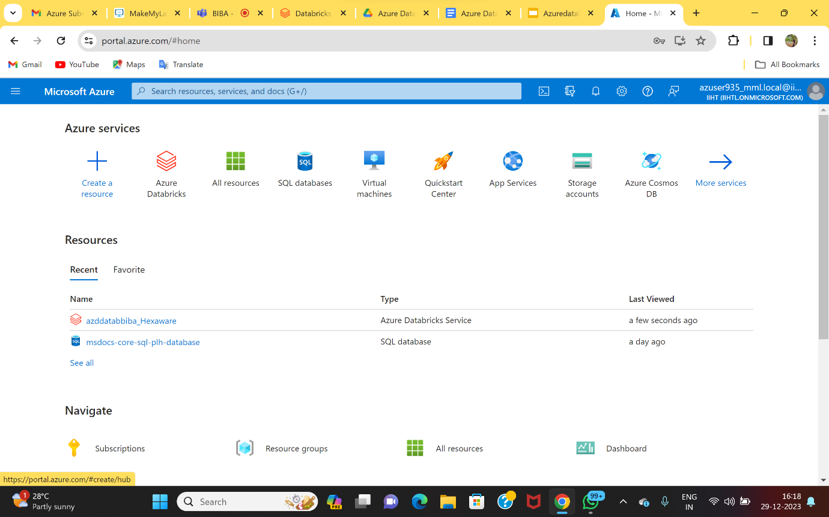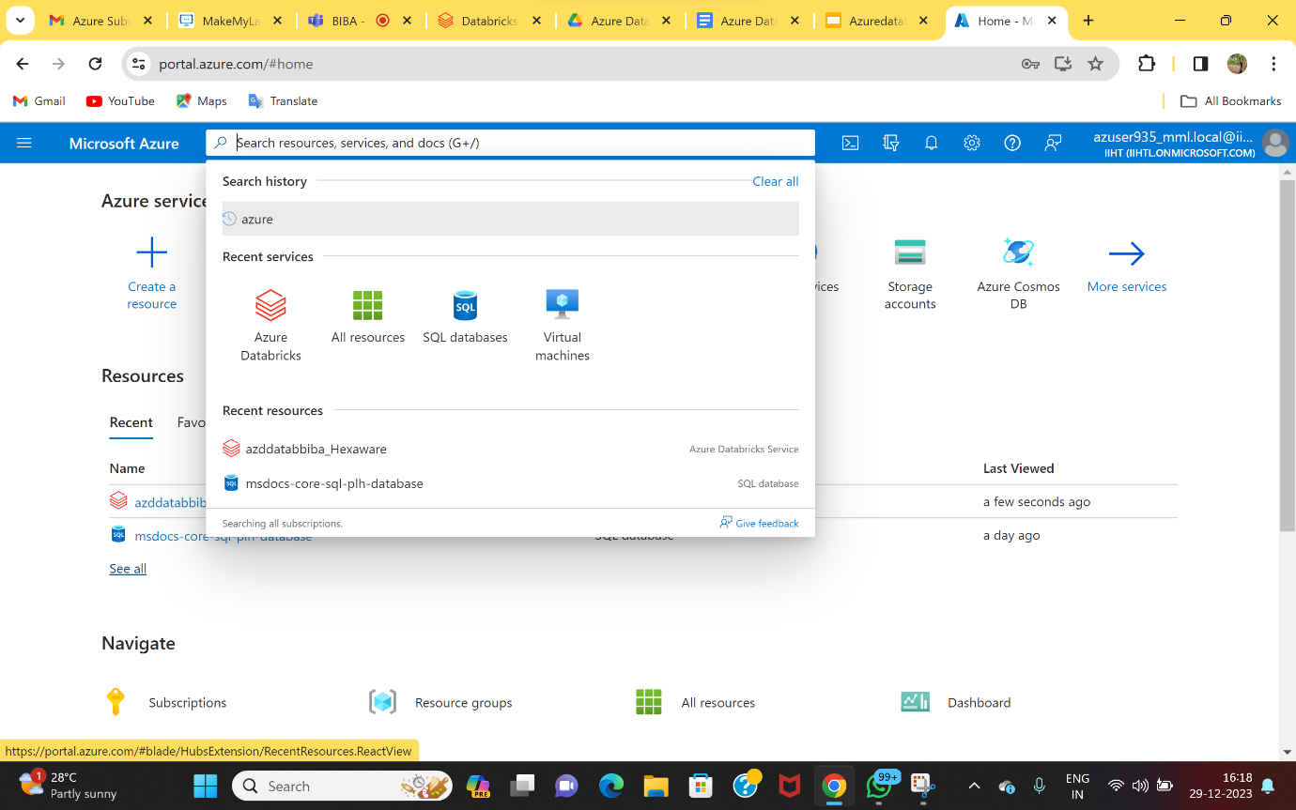

🡪Opening the already created Azure Databricks resourse.

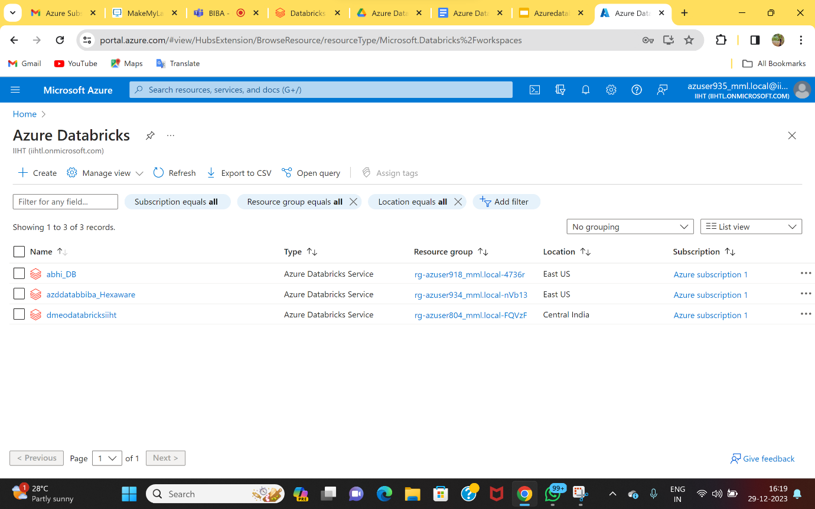

🡪 After Opening, now launching the Azure Databricks workspace.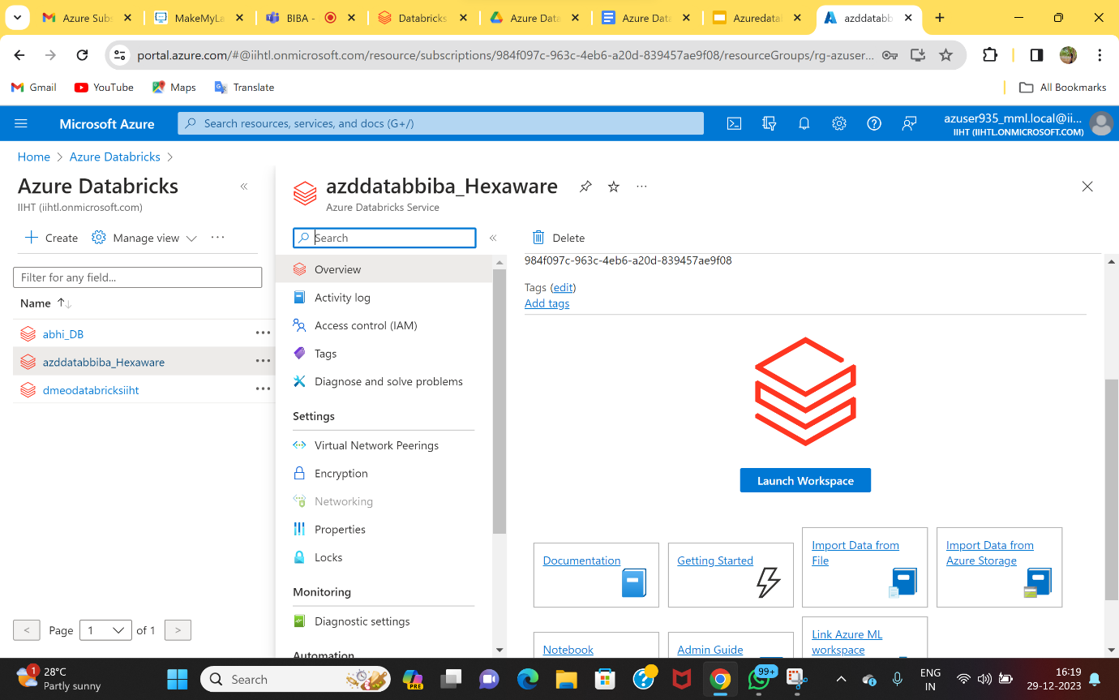

🡪Signing in to the Azure Databricks account.

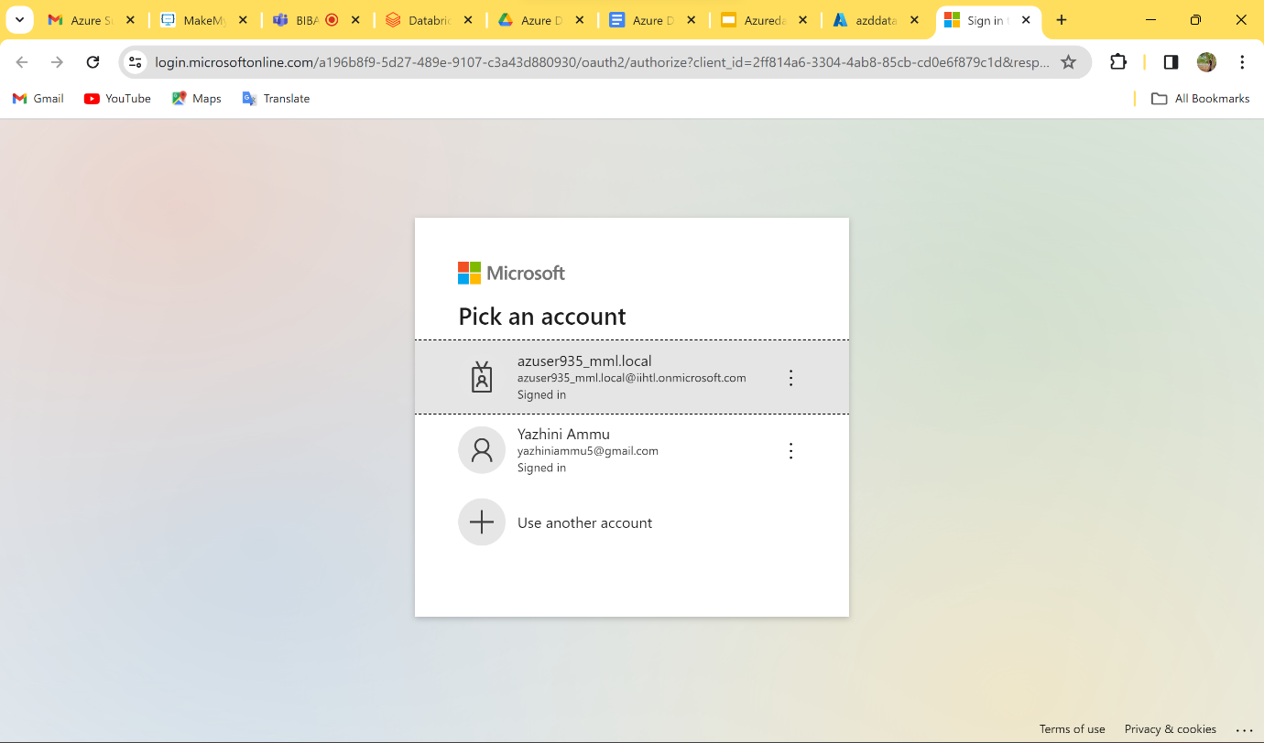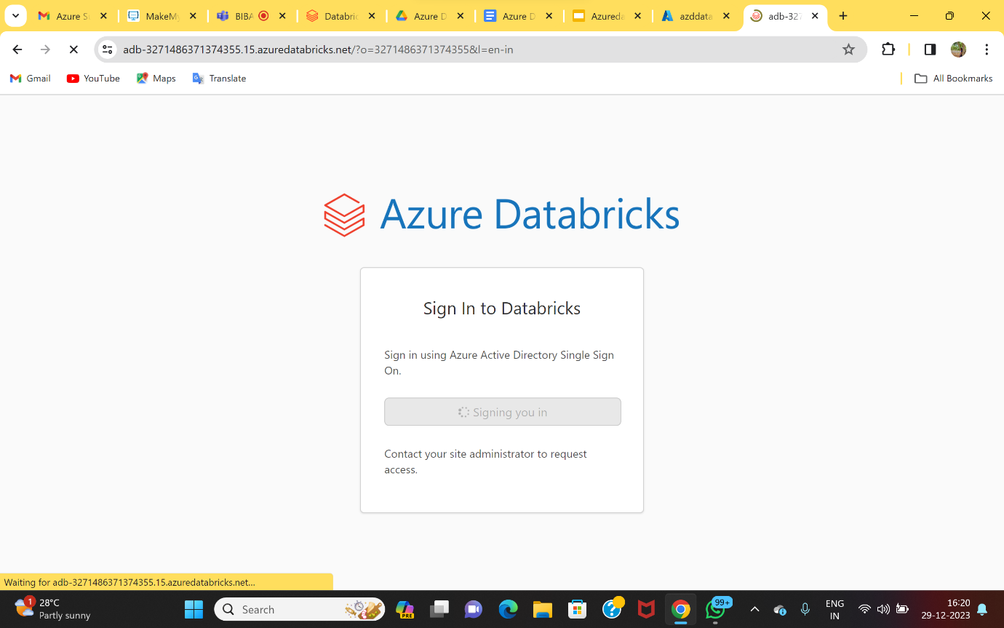

🡪Now, clicking ‘new’ to create a cluster using a already created resource.

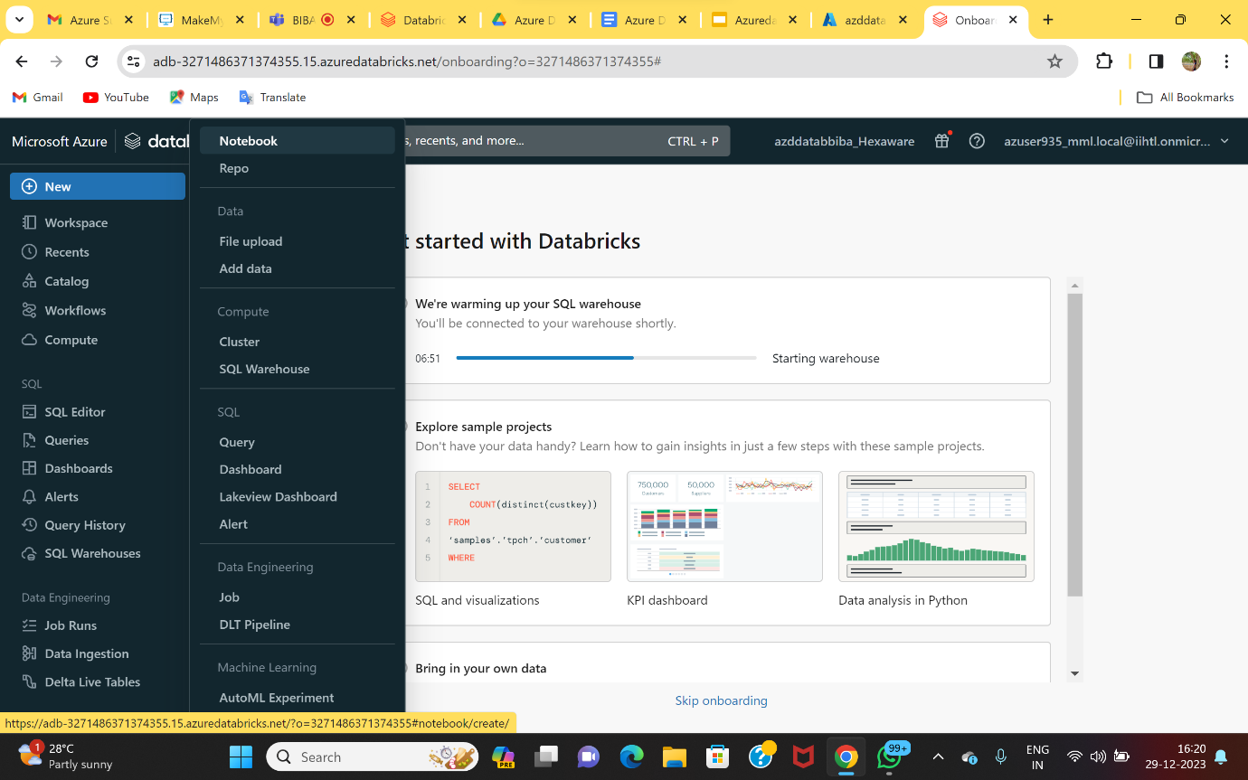

🡪After creating the cluster ,opening a notebook and we can able to code on the workspace.

